

**ANTI-BULLYING POLICY**

**RATIONALE**

Willaston School is completely opposed to bullying and will not tolerate it. It is entirely contrary to the values and principles we work and live by – Fair, Respect Safe.

All members of the school community have a right to work in a secure and caring environment.

All members of our school community have a right to be free from abuse linked to any of the protected characteristics outlined in the Equality Act 2017”

Protected characteristics:-

* Sex
* Race (colour, nationality, ethnic or national origins)
* Disability
* Religion or belief (religious or philosophical belief
* Sexual orientation
* Gender reassignment (undergoing, undergone or is proposing to undergo process of reassigning their sex)
* Pregnancy or maternity
* Marriage or civil partnership
* Age

We do acknowledge that there is a reason behind unwanted behaviour, though often the reasoning is initially unclear. As such, in cases of bullying all involved parities should be treated with sensitivity and discretion during any investigation into their actions.

**PRINCIPLES**

• Pupils have a right to learn and play free from intimidation and fear.

• The needs of the victim are paramount.

• Schools will not tolerate bullying behaviour.

• Bullied pupils will be listened to, as will those who are accused of bullying.

• Reported incidents will be taken seriously and thoroughly investigated.

•Pupils are encouraged to experiment and express themselves though their play.

**DEFINITION OF BULLYING**

In a school environment it is to be expected that children will not always ‘get on’ and there will, what we consider to be ‘normal relational conflict’. A distinction needs to be drawn between ‘bullying’ and ‘normal relational conflict’.

occasional

Power balance

Remorse and effort made to resolve

accidental

Imbalance of power

repeated

deliberate

No remorse

Following a full and considered consultation with the parents, staff and children, (Aut 2017) , with information gathered from all parties, bullying has been defined as repeated, aggressive behaviour intended to hurt another person, physically or psychological, often involving an imbalance of power.

We apply the S.T.O.P principle. Several Times On Purpose.

**Repetitive – happens more than once**

**Intentional – done on purpose**

**Involves an imbalance of power**

Bullying is an act of aggression, causing embarrassment, pain or discomfort to someone. It can take a number of forms; physical, verbal, making gestures, extortion and exclusion. It is an abuse of power. It can be planned and organised, or it may unintentional. It may be perpetrated by individuals or by groups of pupils.

**FORMS OF BULLYING**

* abuse linked to any of the protected characteristics outlined in the Equality Act 2017 (see above)
* Physical violence such as hitting, pushing or spitting at another pupil.
* Interfering with another pupil’s property, by stealing, hiding or damaging it.
* Using offensive names when addressing another pupil.
* Teasing or spreading rumours about another pupil or his/her family.
* Belittling another pupil’s abilities and achievements.
* Writing offensive notes or graffiti about another pupil.
* Excluding another pupil from a group activity.
* Ridiculing another pupil’s appearance, way of speaking or personal mannerisms.
* Misusing technology (internet or mobiles) to hurt or humiliate another person.

Though each of these examples can be recognised as bullying, bullying is not always clear and sometimes such behaviour maybe be exhibited in a ‘play frame’ with the full consent of all the children involved. Such behaviour should be monitored but adult intervention should not occur without consideration of the wider picture.

**RESPONSIBILITIES OF ALL STAKEHOLDERS** 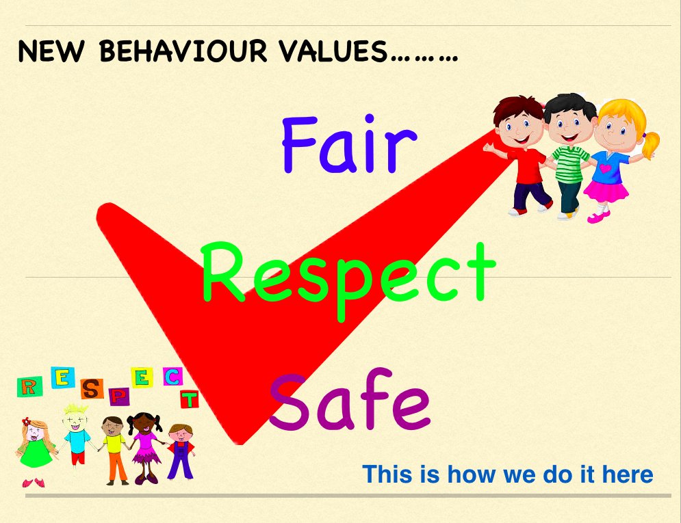

**The Responsibilities of Staff**

**Our staff will**

• Uphold our values of Fair Respect Safe

• Demonstrate by example the high standards of personal and social behaviour we expect of our pupils.

• Discuss bullying with all classes, so that every pupil learns about the damage it causes to both the child who is bullied and to the bully and the importance of telling a teacher about bullying when it happens.

• Be alert to signs of distress and other possible indications of bullying.

• Listen to children who have been bullied, take what they say seriously and act to support and protect them.

• Report suspected cases of bullying to Mrs Burton for a decision to be made if any further investigation is deemed necessary.

Parents will be informed if a child is considered to have been bullied/bullying.

• Follow up any complaint by a parent about bullying, and report back promptly and fully on the actions taken.

• Deal with observed instances of bullying promptly and effectively, in accordance with Bullying agreement.

**The Responsibilities of Pupils**

We expect our pupils to:

**Uphold our values of Fair, Respect Safe.**

• Discuss, read and sign the bullying agreement (Yearly) and display in their class.

• Refrain from becoming involved in any kind of bullying, even at the risk of incurring temporary unpopularity.

• Intervene to protect the pupil who is being bullied, unless it is unsafe to do so.

• Report to a member of staff any witnessed or suspected instances of bullying, to dispel any climate of secrecy and help to prevent further instances.

**Anyone who becomes the target of bullies should:**

• Not suffer in silence, but have the courage to speak out, to put an end to their own suffering and that of other potential targets.

**The Responsibilities of Parents**

We ask our parents to support their children and the school by:

• Watching for signs of distress or unusual behaviour in their children, which might be evidence of bullying.

• Advising their children to report any bullying to (their class teacher or any staff member) and explain the implications of allowing the bullying to continue unchecked, for themselves and for other pupils.

• Advising their children not to retaliate violently to any forms of bullying.

• Being sympathetic and supportive towards their children, and reassuring them that appropriate action will be taken.

• Informing a member of staff of your concerns.

Updated September 2019 following Equality Act 2017