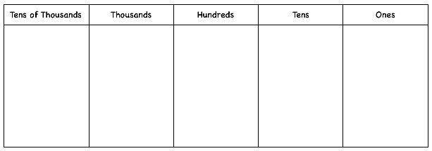

34,608

Number sentence:

Place value Grid:

Expand it:

Number line:

Part-whole model:

In words: